1.WEBSITE SPECIFICATION
a. Website Objectives and Business Goals
The main objective of this website is to provide a professional digital platform for the Security Systems company, where clients can learn about the company’s products and services, request quotes, and access support.
GOALS
The company’s main goal will be to showcase the company’s security solutions such as CCTV systems, access control, and perimeter protections and introduce their newly introduced service which is Cash in Transit services.
One of its main goals is to build trust and integrity through detailed product information, certification, and client testimonials.

b. Target Audience (Demographics and Technical Aptitude)
Demographics
Security Systems will mainly be targeting Homeowners and tenants seeking CCTV or alarm installations not forgetting the commercial side to where it will also be providing its services to business owners.
Mostly it will be targeting people from ages as low as 25 years old to 70 years old since statistics show that is when an average Motswana citizen is out of school and know are starting to venture in different opportunities.
Technical Aptitude
The website is set to be user friendly for everyone even if one is not that familiar with technology more especially the elderly people.
According to our research we found out that the website is to mostly be visited on mobile devices so it will be of our best ability o make it fully responsive.
c. Type of Website
The website we are creating should include
Product information pages for instance CCTV, Alarm Systems, biometrics, electric fences.
Service pages for example installation, maintenance, consultancy.
Contact and quotation request forms
FAQ and support information
2. INFORMATION DESIGN AND TAXONOMY
INFORMATION STRUCTURE
The website is to be made in a way that its architecture will group content based on customer needs and how security solutions are typically researched. So, we will be looking at research made in the past mostly looking at chrome searches and google looking at solutions that are being researched the most so that once the website is up and running will be easy to interact with also easy to use.

SITE MAP

Home
│
├── About Us
│ ├── Company Overview
│ └── Mission & Vision
│
├── Services
│ ├── Manned Guarding
│ ├── CCTV & Surveillance
│ ├── Alarm Systems
│ └── Access Control
│
└── Contact Us
├── Contact Form
├── Phone & Email
└── Location Map

3.PAGE TEMPLATE DESIGN
Description of page template
Header; contains the logo, search bar and moto of the company
Navigation Bar; contains all the pages et home, about, services, contact
Footer; contains a little bit of the company’s achievement’s and contact information

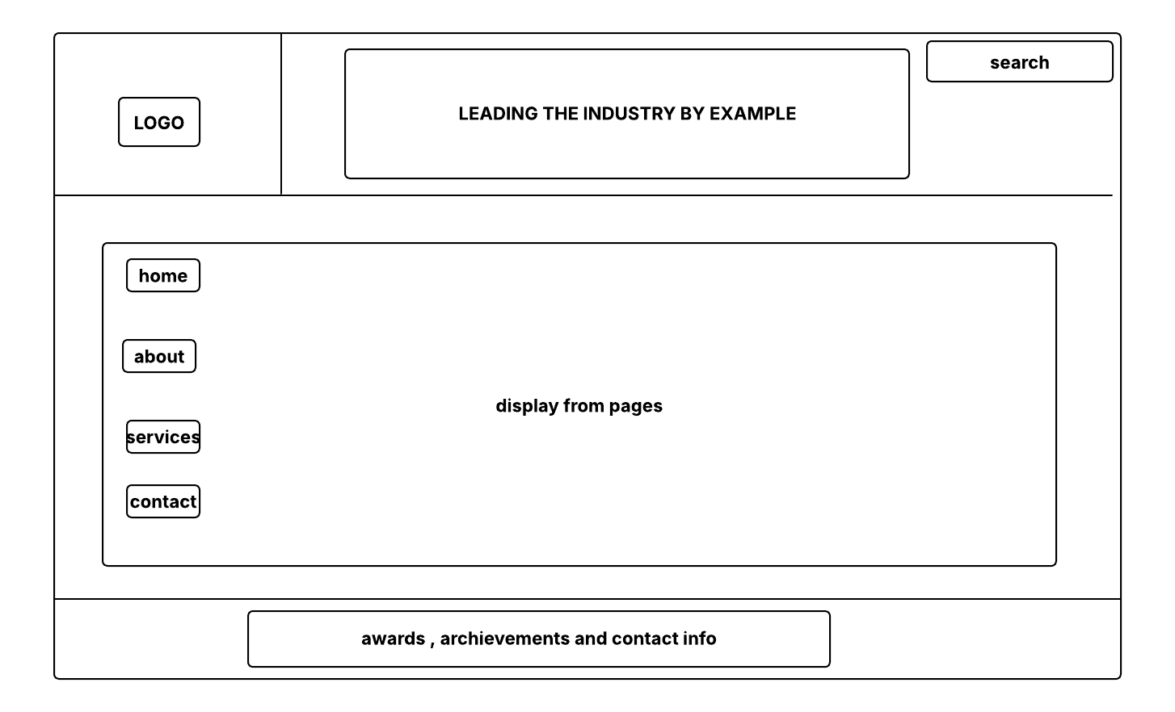

4. TECHNICAL BRIEF
The website well be created using the help of following tools:
Development Tools
HTML5 and CSS3 – for website structure and styling
JavaScript – Interactivity such as menus, sliders and forms
Bootstrap – To ensure mobile responsiveness

